STEPS TO RUN THE DATABASE SYNC
- OneDrive installation steps:
Experienced users may skip these detailed steps and proceed with the installation as necessary.
- Install OneDrive. If OneDrive is already installed, ignore this step.
- Run the OneDrive software and sign in (click as shown in the picture below, first click on 1 and then click on 2)
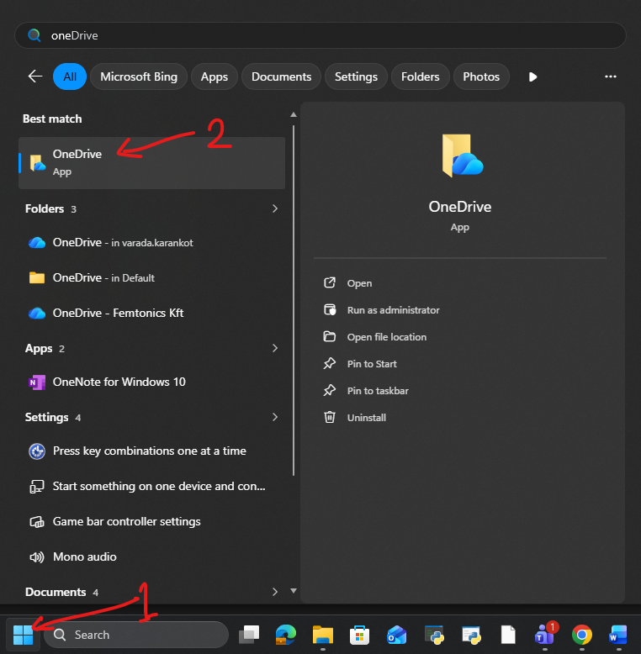

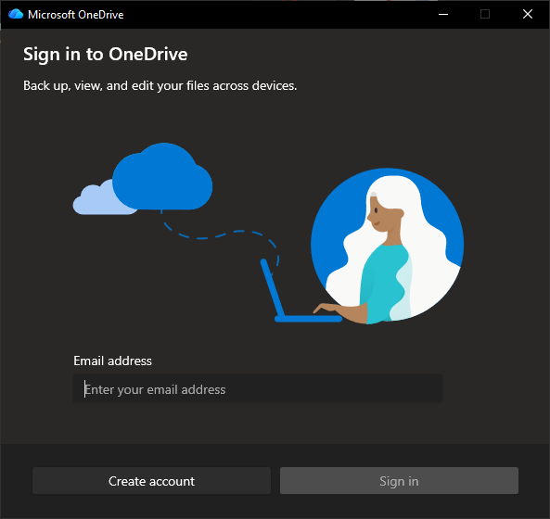

- Click on ‘No, this app only’.

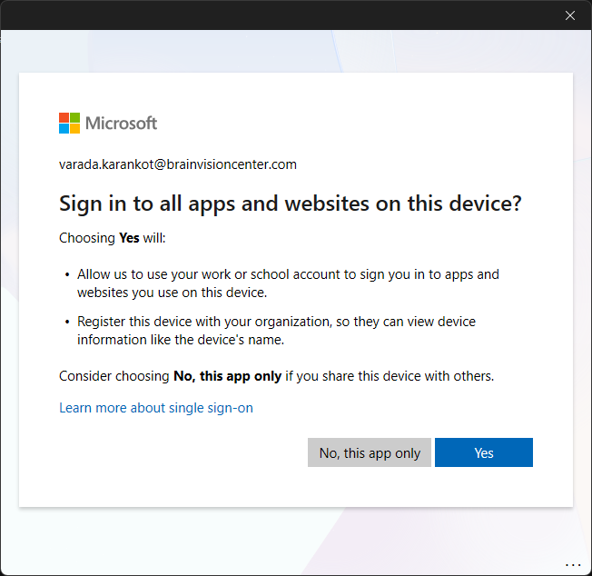

- Click on ‘Next’

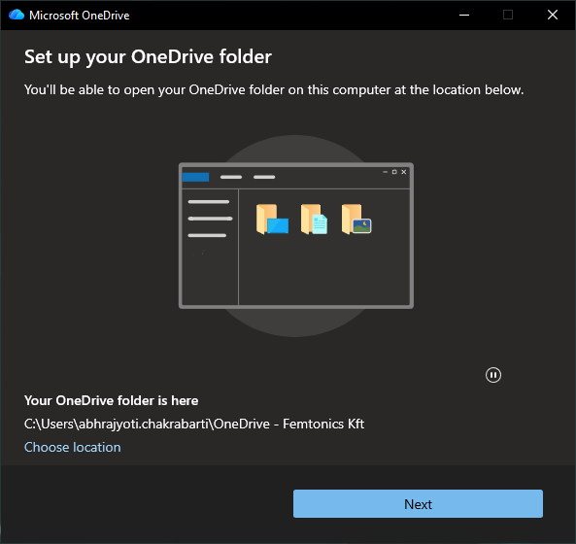

- Click ‘Use this folder’

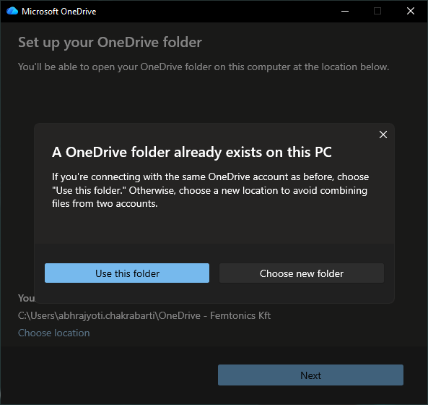

- Disable all the backup and then click ‘Next’
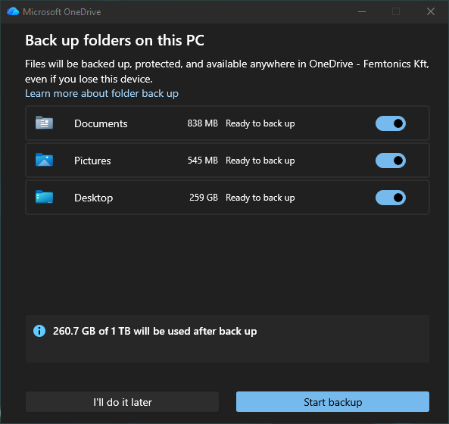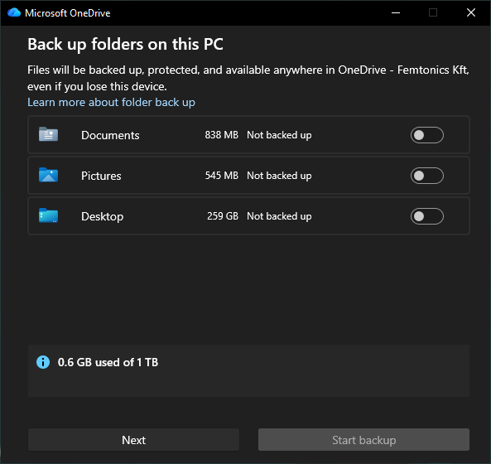

- Click ‘Next’ in these windows
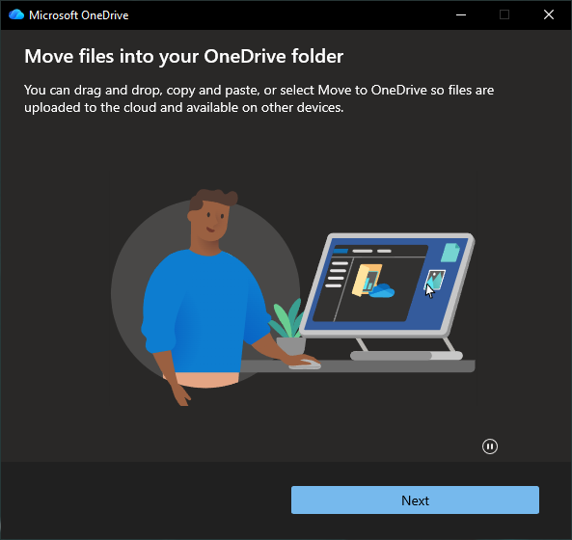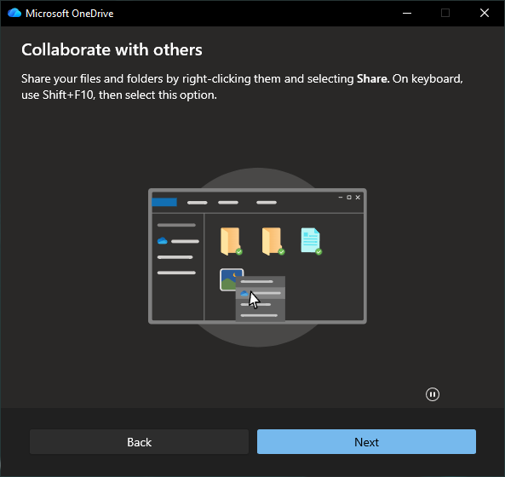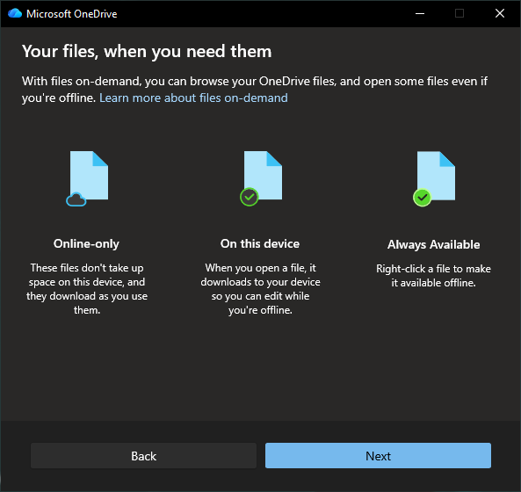

- Click on ‘Not now’
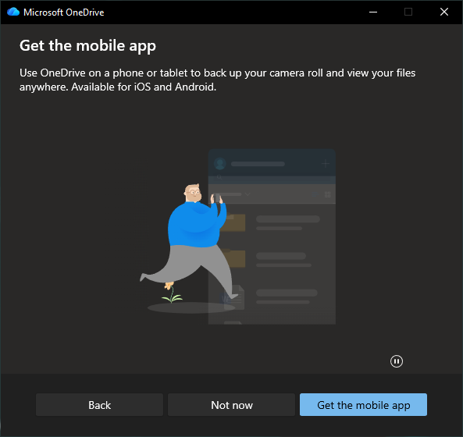

- Click on ‘Open my OneDrive folder’
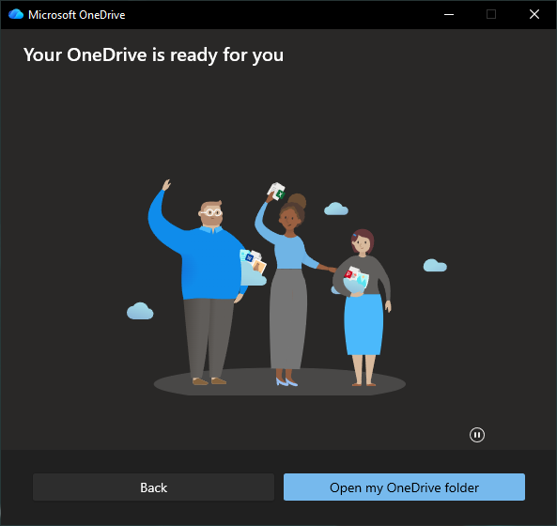

- In the next window that opens, try to look for a folder ‘2pteam - Documents’. If it exists, move to step 14. If the folder does not exist, follow the next steps.
- Open your browser (like google chrome), and log into your office365 account. Then go to ‘Sharepoint’ (link).

- Click on ‘2pteam’
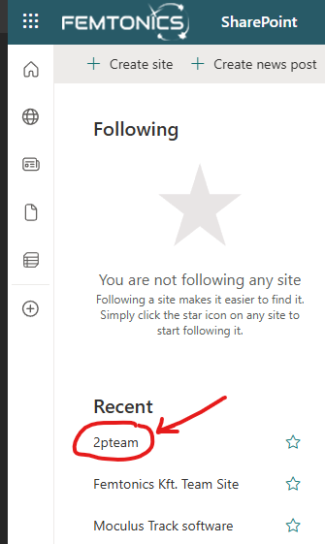

- Click on ‘Documents’

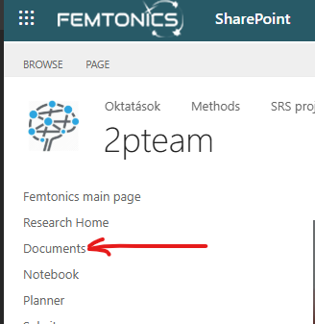

- Click on ‘Add shortcut to OneDrive’
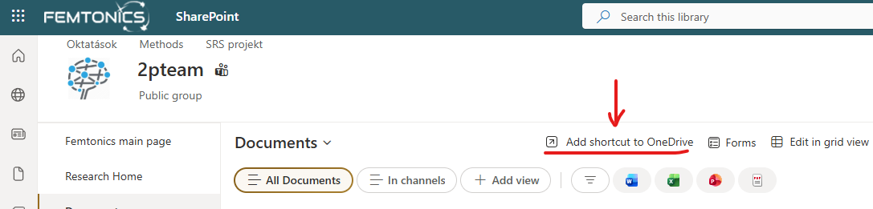

- In your windows explorer, within the ‘OneDrive’ folder (which opened after step 7), you will notice this folder now being present

The blue circular arrows indicate folder synchronization from cloud to your PC is ongoing.
- Go inside the ‘2pteam – Documents’ folder and find the folder ’Tables’. Then go inside the ‘Tables’ folder.
- You will find an excel sheet ‘Injection diary.xlsx’ and it might have a blue cloud logo under the Status column

If you see the blue cloud, then double click on the ‘Injection diary’ excel sheet. The excel sheet will open up, and you can close it. Now the excel sheet will have a different Status logo

This means the excel sheet is now locally available in your computer.

NOTE: Even if the cloud logo does not change to the green-white check mark for the ‘Injection diary’ excel sheet, don’t worry. Check if the file occupies space in your computer, like this

As you can see, the file now occupies 1136 KB in your computer, which means it is downloaded in your computer and now you can proceed to the next step.

- You may close the windows explorer window now.

- Setting up the GitHub repository:
Users who are already familiar with GitHub may skip the following steps and proceed as necessary to download the repository (repo link). These steps are for users who are new to the GitHub platform.
- Open up your browser (like google chrome) and visit this link.
- Click here

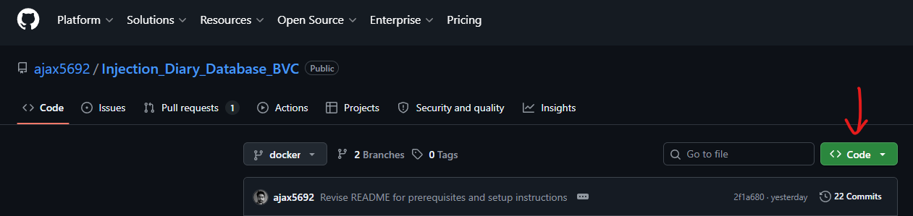

- Click here

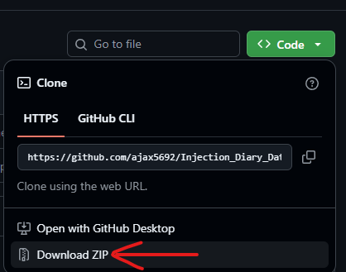

- Let the download finish. Once the download finishes, extract the contents of the zip folder.

- Setting up the docker desktop:
Experienced users may skip these detailed steps and proceed with the installation as necessary.
- Run the downloaded docker installation file. The file name is ‘Docker Desktop Installer.exe’
- Proceed with the installation and when this comes up (see picture below), enable the ‘Allow Windows Containers to be used with this installation’ (the second option from the top). Then click on ‘ok’
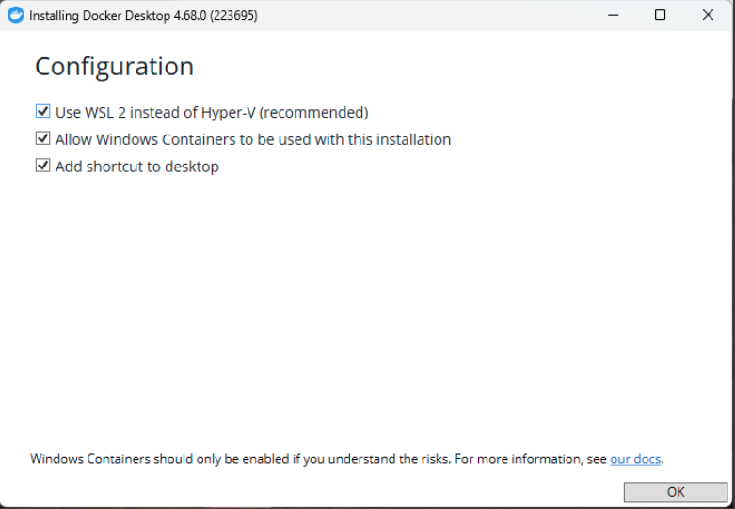
- After successful installation. It should look like this.

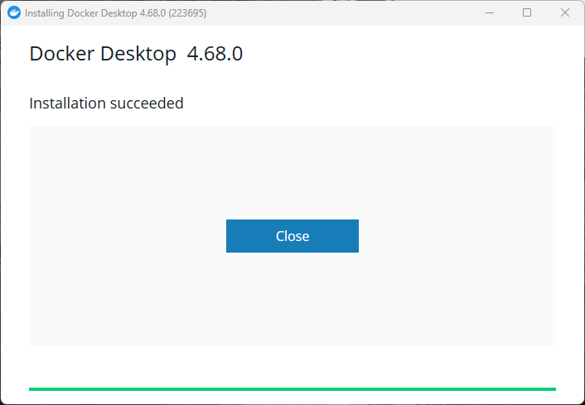

- Click on ‘Close’. You might be prompted to restart your computer. If prompted, then restart. Otherwise, proceed to the next step.

- You might be prompted to update your Windows Subsystem for Linux. If you are not prompted for this, then skip to step 8

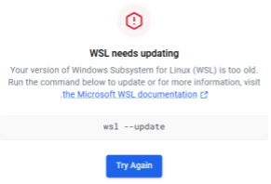

- To do that, open Command Prompt on your computer and type in ‘wsl –update’ (without quotation marks)
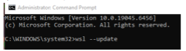

- Once the update finish you can close the Command Prompt and restart Docker Desktop. You most likely will now be asked to restart your computer

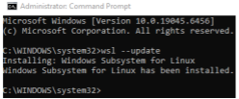

- Search for the ‘Docker desktop’ app from the start menu and run it
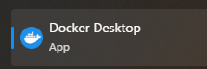

- Click on ‘Accept’
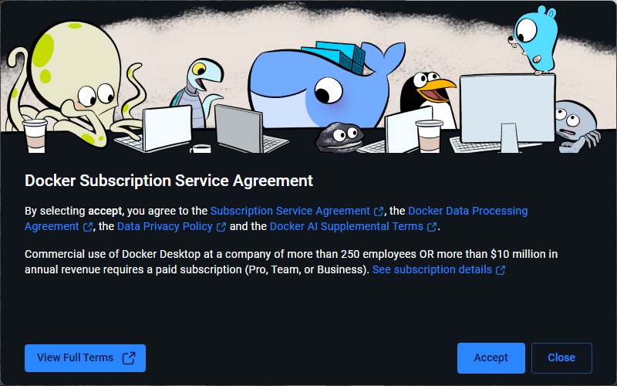

- Click on ‘Skip’
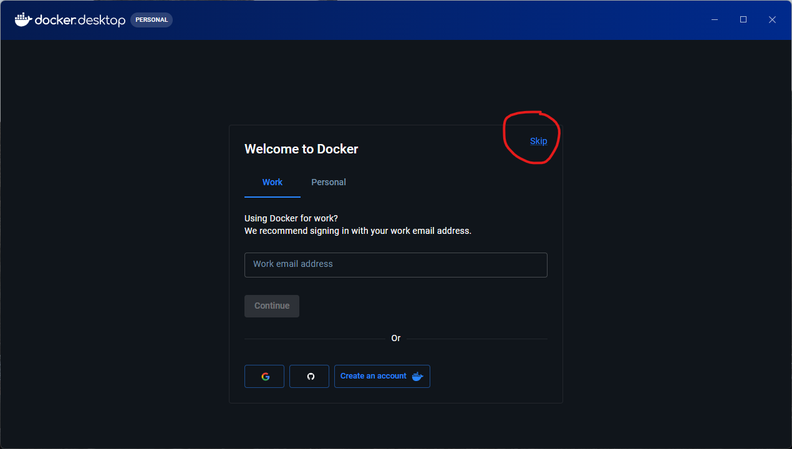
- Click on ‘Search’ and type ‘ajax730’ without the quotes (look for two pictures below)

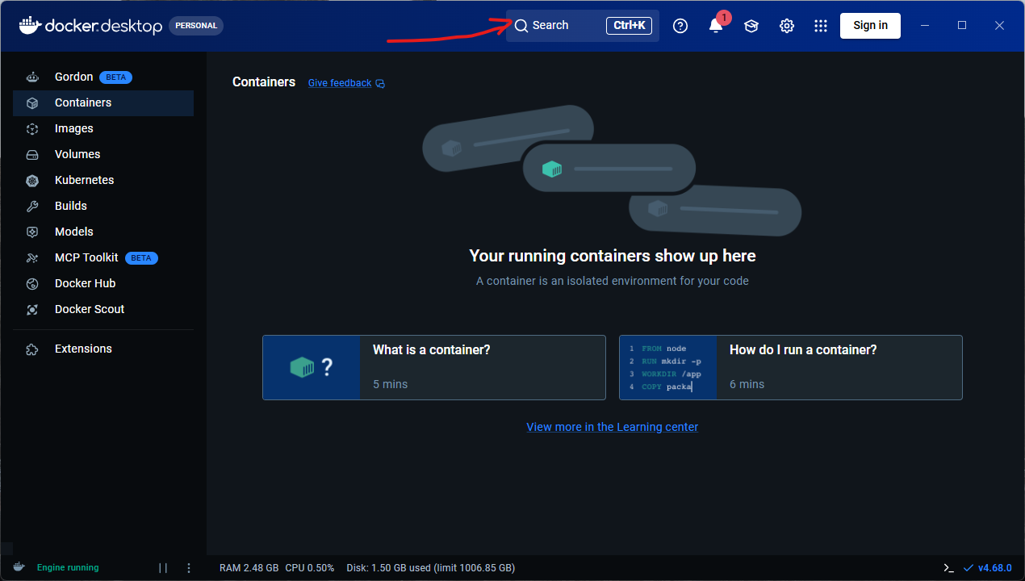

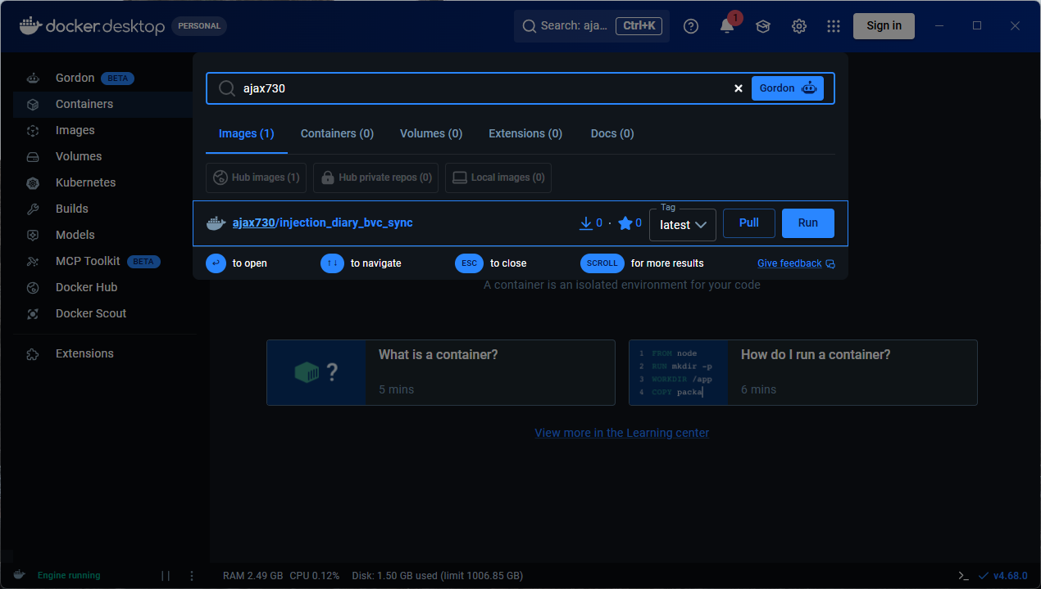

- Click on ‘Pull’
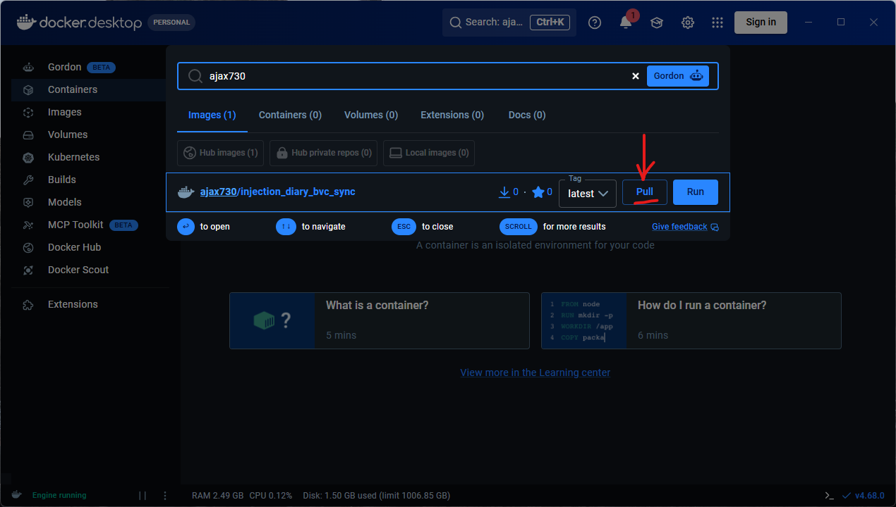

- Once the ‘Pull’ is successful, you will find this under the ‘Images’ section
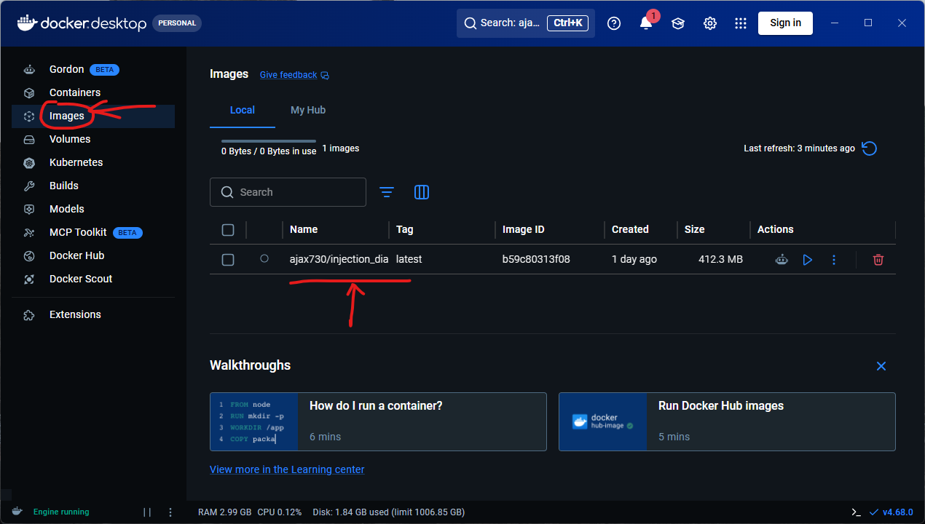
- All is set now and we are good to run the database sync.
- Go to the extracted folder path in step B4. It should look like this
……\Injection_Diary_Database_BVC-docker\Injection_Diary_Database_BVC-docker\Python_SQL
- Look inside the ‘Python_SQL’ folder. There should be a file called ‘run_sync.bat’ (or run_sync without the file extensions). Select it and hit Enter. Then click on ‘Run’. This should update the existing injection_diary.db file, which is the final goal.
- If the database if updated successfully, then you would see something like this
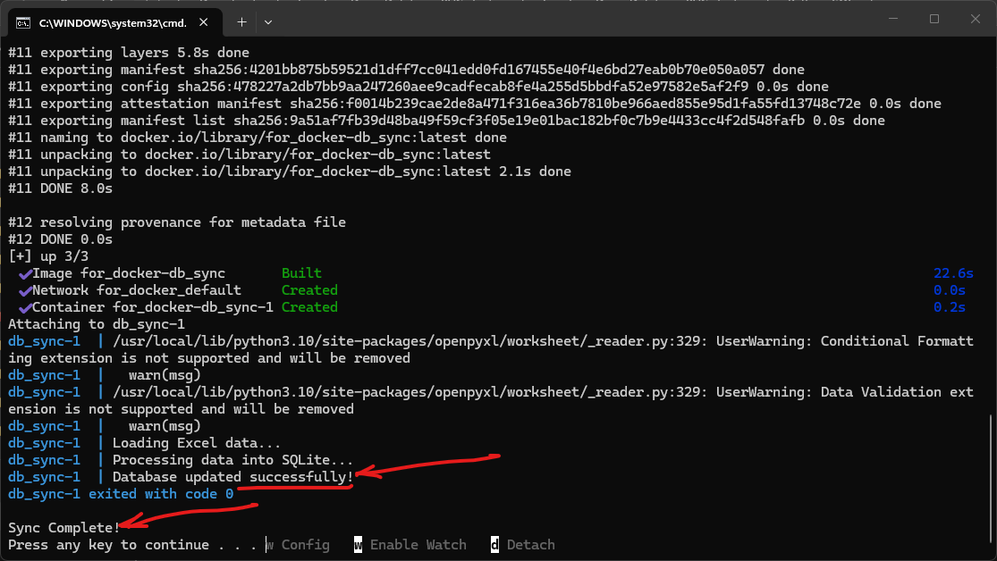
You can then click on this window and press any key in the keyboard to close this window. That’s it

